Personal Learning Environments
Using Symbaloo in the Classroom
Directions: This handout details step-by-step directions on how to register for a Symbaloo Account. Also covered in this document will be how to edit/manage your home page, search for existing Webmixes, and creating your own.
Dr. Roland “Buddy” Weldon
1/22/2012

How to Create a Symbaloo Account
- Access www.symbaloo.com Click on “Create Free Account” on the top right of the viewing screen.

- Include the necessary information each of the designated fields. Your name¹, your school email² and designated password³ ⁴. Deselect the “I want the inside scoop⁵” Select the “I agree to Symbaloo’s terms⁶”… Click on the button located on the bottom of the frame.
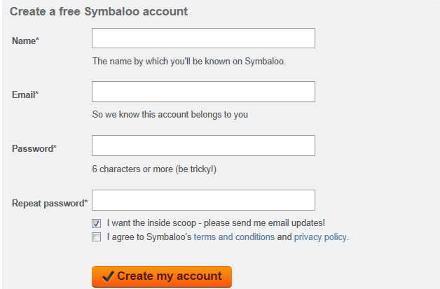
6
5
3
2
1
4

- Click on the button….
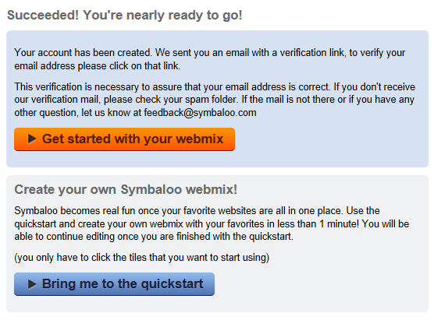
- Click on the tiles you would like to add to your Symbaloo webmix. If you click "Create webmix" at the bottom, a new page with the selected tiles will be created.
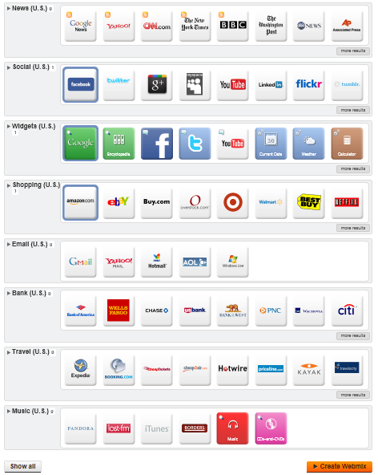
- At this time, do not add any other webmixes to your choice….just click on the button on the bottom right.
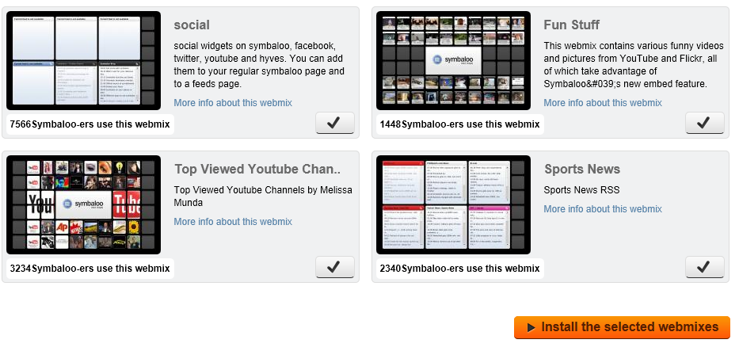
- Symbaloo will preview your new webmix from the selections that you have made. Below, is the one I have created from my selections. (Note how the tiles are grouped). Click and drag allows you to move the tiles to blank areas for further customization.
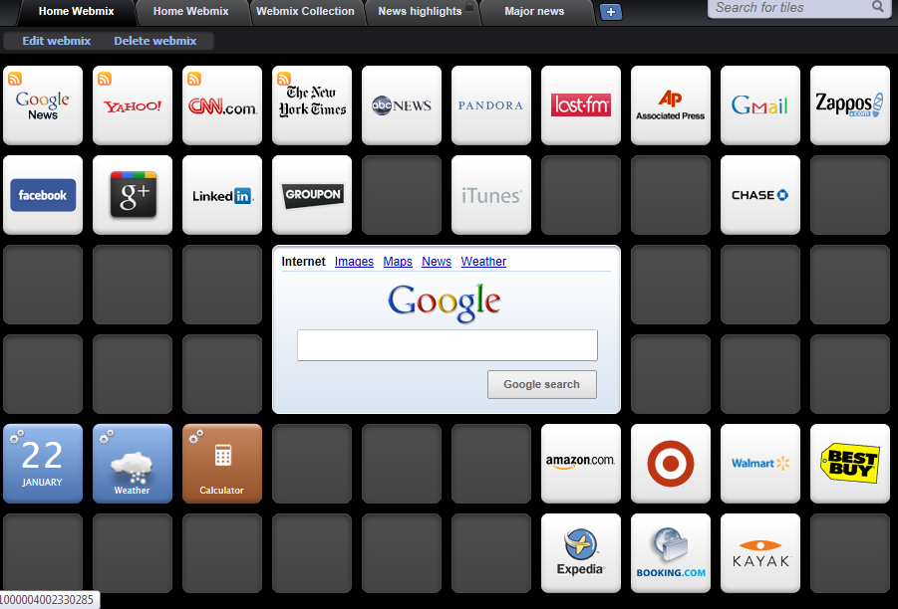
- Now you have 2 different tabs designated as “Home Webmix”. Change the name of the first one to “Practice” by clicking on the tab underneath the first tab. This automatically opens the editing toolbar () were the button allows you to change the name of the webmix from “Home Webmix” to “Practice”. Click when done.
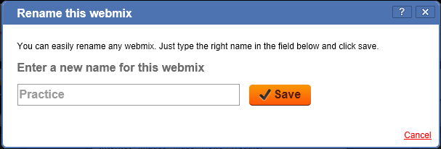
- The Symbaloo user now has 5 Webmixes (collections of web resources) that you can edit (adding or deleting tiles) to your own personal needs. This is the beginning of making a Personal Learning Environment.

- Clicking on the designates a start page similar to a group of icons that are used in the desktop area in the popular Windows environment.
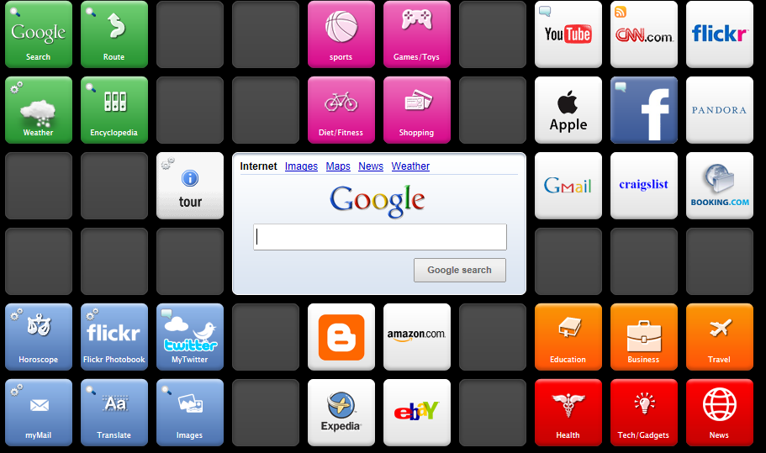
- Right-click on tiles will provide users options to edit designated tiles. This is the menu provided when right-clicking on the 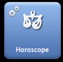 button. The options to open tile, edit the tile options, move it from its current location, and deletion are available. Also tiles can be removed by click and dragging a tile to the top of the screen and dropping it into the red garbage can icon (top right).
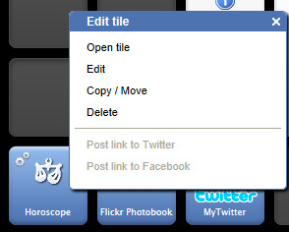

- Adding a tile to your Home Webmix. Click on a blank tile area Click on “click here to create your own tile”
- Complete the 3 step process to create a tile. Add the physical address of the website¹. Click on the second box to confirm address. Determine if you want the name to be present on box (select box option) and choose text color². Add color to tile and icon OR choose a picture that you want as background³. Click to add new tile.
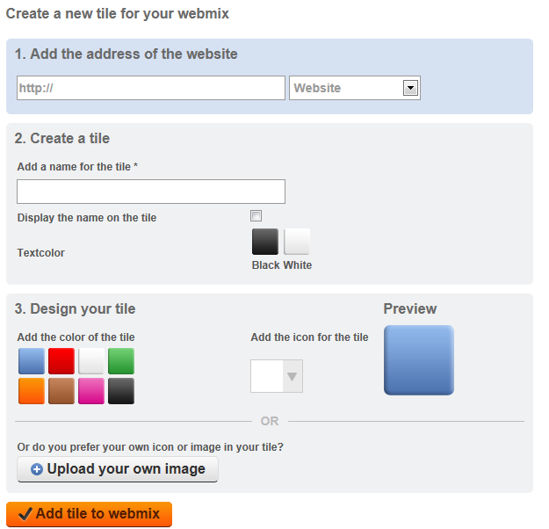
3
2
1
- Click and drag new tile into designated location…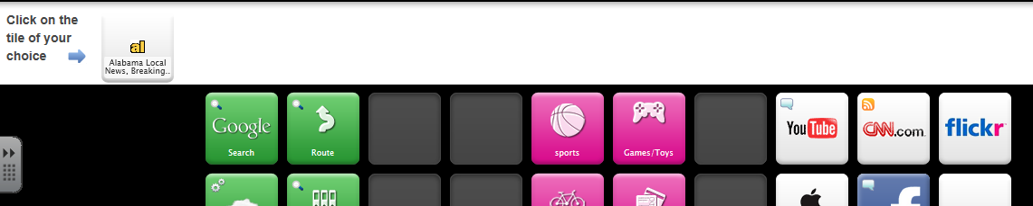

- Reviewing content in the (2nd tab) this is what it will look like. Symbaloo has given you a collection of resources in each tile. Some may be of use to you. For example, click on the red Food Recipes icon in the bottom right area. Click on the Soup Recipes (2nd row, 2nd column). Provided will be a webmix of collection of recipes…pretty neat, huh?

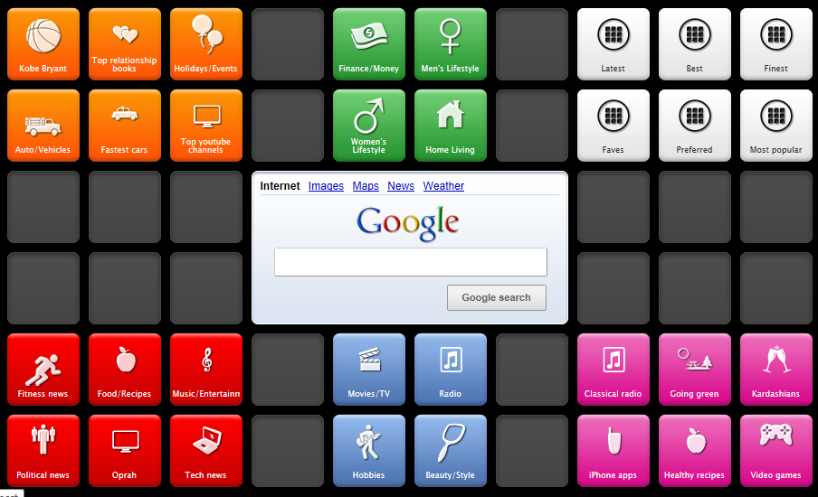

- Reviewing content in the (3rd tab) this is what it looks like. This webmix feature pictorial shortcut to current news events via yahoo. Clicking on any picture will take you to today’s story.
- Reviewing content in the (4th tab) this is what it looks like. This webmix is a live RSS feed with news stories from multiple news outlets and great place to begin research/ current events.
- How to find existing webmixes already created. I have one titled “Classroom Resources”…we are going to add this webmix to your collection. Click the button in the top right area choose the section option on the right and enter “Classroom Resources” then click
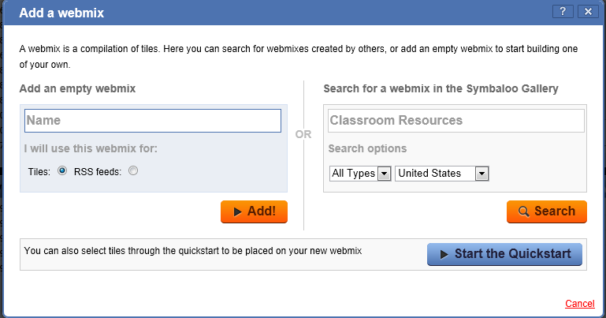
- Go to the 3rd page of results and you find the one “Classroom Resources” with 635-665 users click on the right side then click button on the top or bottom right. This will automatically add this webmix to your collection designating this as a 6th webmix in your collection. Note that to remove webmix tabs previously opened click on the webmix then then button.

